**[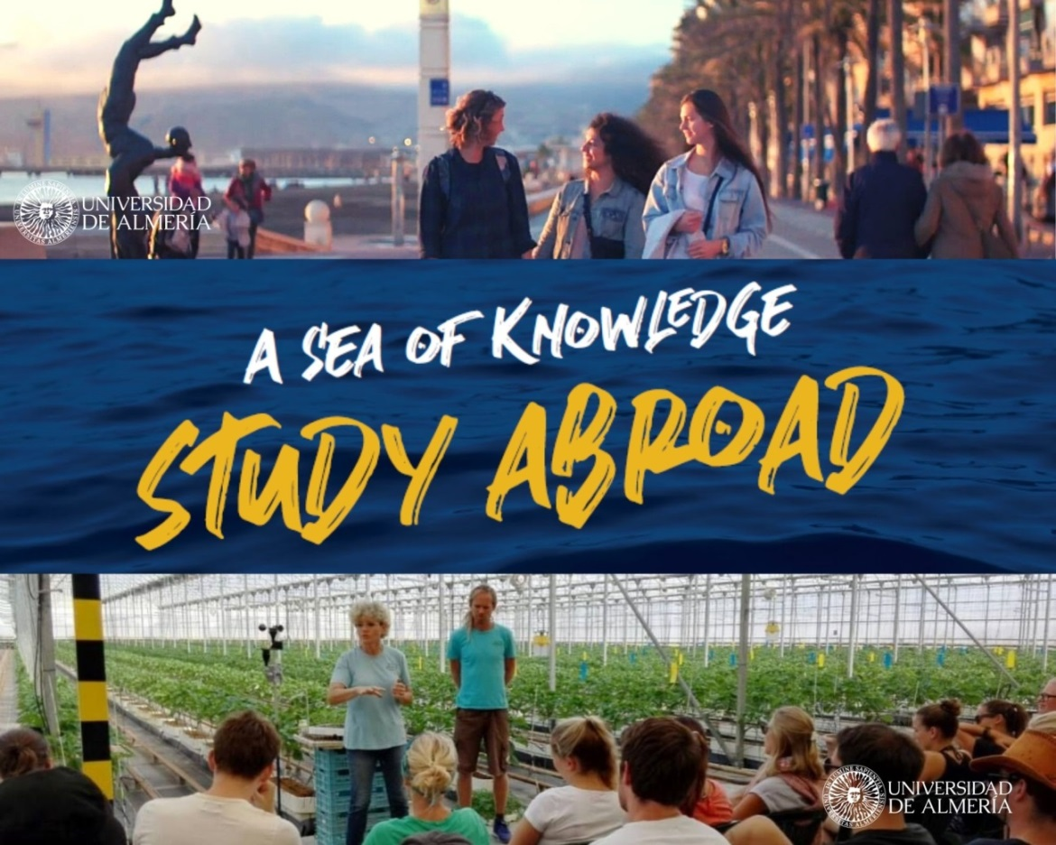](http://www.ual.es/sabroad)**

|  |
| --- |
| **[COURSE TITLE]**  **Dates: xxxx XXth – July XXth 2025**  **Teaching hours:**  **Area of knowledge:**  **Academic coordinator/s:** |

|  |
| --- |
| INTRODUCTION [250-300 words] |
| (Please briefly introduce the field of knowledge and the main related concepts included in the course. Also, try to emphasize the potential of the University of Almeria in this thematic area). |

|  |
| --- |
| MAIN GOALS |
| (Please briefly list the objectives of the course. Feel free to add as many rows as needed). |
|  |
|  |
|  |

|  |  |
| --- | --- |
| CONTENT | |
| Course Modules | **Description** |
| MODULE A:  Name |  |
| MODULE B:  Name |  |
| MODULE C:  Name |  |
| MODULE D:  Name |  |
| MODULE E:  Name |  |

|  |  |
| --- | --- |
| COURSE METHODOLOGY [200-250 words] | |
| In-lab sessions | Company visits |
| Academic visits | Talks |
| Lectures | Others |
| (Please check the correct option, and briefly comment on how it will develop. If you select “others”, please explain the type of activity). | |

|  |
| --- |
| REQUIREMENTS [100-150 words] |
| (Please specify if the students need to meet any criteria for their enrollment in this course, such as previous knowledge, having a personal computer, reading some bibliography, etc.). |

|  |
| --- |
| ACADEMIC VISITS & NETWORKING |
| (Please, list and briefly describe:  Specify here any information about talks with experts, visits or any other activities.  Include, at least, 1 visit per week to different places of interest related to the course: companies, research centers, public institutions, non-profit organizations…). |

|  |
| --- |
| ASSESSMENT |
| (Please write how the course will be evaluated, e.g. written assignment, attendance, final report, participation…). |

|  |
| --- |
| LECTURERS |
| (Please list all lectures and professors taking part in the course, as well as a brief résumé –1 or 2 paragraph– of each one. Feel free to add as many boxes as needed).  Professor ….  *xxxxx* |
| Professor ….  *xxxxx* |
| Professor ….  *xxxxx* |
| Professor ….  *xxxxx* |
| Professor ….  *xxxxx* |
| Professor ….  *xxxxx* |
| Professor ….  *xxxxx* |

**Organized by**

*Vice-Rectorate for International Relations*

Universidad de Almería

Tel.: +34 950 01 5816

E-mail: [sabroad@ual.es](mailto:sabroad@ual.es)

CAU: [Contacta con nosotros - Universidad de Almería](https://www.ual.es/contacta)

Web: <https://www.ual.es/en/estudios/study-abroad?idioma=en_GB>

[@sabroadUAL](https://twitter.com/sabroadUAL?lang=es) | [@studyabroadUAL](https://www.instagram.com/studyabroadual/?hl=es) | [@studyabroadsummercoursesalmeria](https://www.facebook.com/studyabroadsummercoursesalmeria/)